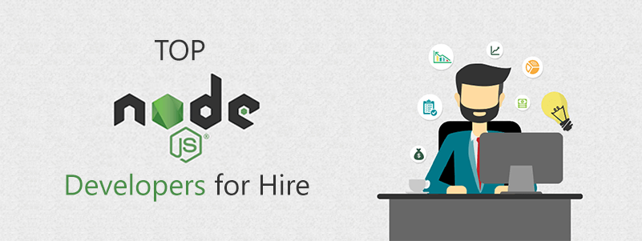

A well researched list of top Node.js developers for hire.

You have already taken a good step by picking up Node.js for your next web project. Now, the next uphill task for you is to hire a technically sound Node.js developer to bring your idea to reality. If you are new in the industry, then you might get confused as everyone claims to be the best. Therefore, you need to be careful before hiring them and outsourcing your development work. In order to make your task easy, we compiled a list of top Node.js developers for hire based on the factors listed below.

- Total work experience.

- Minimum project cost and hourly rates.

- Client reviews and ratings on platforms like Goodfirms, Clutch, etc.

- Client demography they serve and locations they operate.

- Quality of projects developed from the portfolio.

That being said, let's begin our list of best Node.js developers that you can hire to kick-start your project:

**1. VironIT**



VironIT is a custom web and mobile application development company which also offers Node.js development services to its clients. The organization mainly targets medium to large scale businesses and can develop administrative dashboards for apps, IoT software, and other stuff using Node.js for them. The company was founded in 2004 and is based out of Minsk, Belarus. Based on their Clutch profile, they charge a minimum of $5000 for a project and their hourly rates are between $15 to $25 per hour.

**2 Agicent**



We are one of the best web and [app development companies](https://www.agicent.com/blog/top-10-mobile-app-development-companies-india) in India and [New Jersey](https://www.agicent.com/blog/top-10-mobile-app-development-companies-in-nj) because of our passion for mobile and web application development. Even [Goodfirms acknowledged our hard work](https://www.agicent.com/blog/top-app-development-company-goodfirms) and termed us the best mobile application development company from NJ region. It doesn't matter how complex is your problem, we have got AI and machine learning solutions to build a smarter and scalable project within time and budget. Our highly skilled team of Node.js developers can build admin panels using Node.js for your app, real-time data-driven web app, messengers, music streaming services, etc.

Our Node.js development services:

- API development.

- AJAX and plugins development.

- Chats and Messenger development.

- Backend development.

- MEAN Stack development.

The real benefit of hiring Agicent is that you get a 3 month free maintenance period in which we will handle all the bugs and issues identified post-deployment of your project. Additionally, you also get multiple free consultation sessions with our experienced project managers and top-level management for assistance and guiding you from project development to execution on the ground.

**3 DevTeam.Space**



DevTeam.Space is another Node.js development company based out of Sunnyvale, CA founded in 2015. The company is also into mobile and web application and serves clients from small to medium business markets. Their key clients are Disney, Airbus, Samsung, etc. Based on their Clutch profile, they charge a minimum fee of $5000 and their hourly rates are between $50-$99 per hour.

**4 Addon Solutions Pvt Ltd**



Addon Solutions is another good Node.js developer for hire. The company is based out of India and also marks its presence in Australia, UK, USA, and Europe. They are specialized in mobile app and web development domain and also provide Node.js development services to build admin dashboards, backend, API, etc. Additionally, they also offer SEO services, CMS development, etc. The IT company charge minimum $1000 per project and their hourly charges are less than $25 per hour.

**5 Matellio**



Matellio is a web and software development company from San Jose, CA. Since their inception, they have successfully delivered 500+ projects to a client base scattered all over the globe. The company mainly target clients from small to medium industries and charge a minimum fee of $5000 for a project. If you want to hire them on hourly basis, then it will cost anything less than $25 per hour. In addition to Node.js development, they also offer embedded solutions, cloud implementation, GIS application development, and other IT solutions.

**6 Apptunix**



Apptunix is an IT company from Austin, TX, founded in 2013 which mainly offers web and application development services to its clients. On top of these services, they are also into games and cross-platform apps development. As per their company profile on Clutch, they charge a minimum project fee of $1000 and their hourly charges are less than $25.

**7 Codiant Software Technologies Private**



Codian Software Technologies Private is a Node.js development company from Moline, IL and mainly provides website and app development services. The IT company caters the development requirements of small to medium scale business clients. On top of mobile and web, the company is also actively working in other industry verticals including wearables, IoT, etc. as well. Their minimum project goes up to $5000 and hourly rates are less than $25 per hour.

**8 Planet Web Solutions Pvt. Ltd.**



Planet Web Solutions Pvt. Ltd. is a web and mobile app development company which also offers Node.js development services to its clients. Also, they also provide MEAN Stack, blockchain technology, and digital marketing solutions. Their client base generally belongs to small to medium scale industries. The company hasn't disclosed their minimum project cost, but we do know their hourly charges which are less than $25 per hour.

**9 Itexus**



Itexus is an IT company from Minsk, Belarus which provides Ruby on Rails, .NET, and Node.js development services. Their web specialization includes social networks, E-commerce solutions, healthcare matching apps, and other similar stuff. Like other top Node.js developers for hire on this list, they also target clients from small to medium markets. They charge a minimum payment of $10,000 for a project and their hourly charges are $25 to $49 per hour.

**10 DashBouquet Development**



Dashbouquet is the last Node.js developer for hire on this list. The company is based out of Minsk, Belarus and was founded in 2014. They are deeply expertise in modern JavaScript based frameworks and also build mobile apps for their clients. If you want to hire them for your project, then you have to pay a minimum charge of $10,000. You can also take their services based on the number of worked hours ($25 to $49 per hour).

With this, we sum up our list of top Node.js developers for hire. We hope you will find a good Node.js developer for your next project. You can also take a reference of our [ultimate checklist before hiring any company](https://www.agicent.com/blog/checklist-for-hiring-an-app-development-company) to make a good decision. If you want any company listed here then contact us and after a thorough review, we will add it to this list for the benefits of our readers.

Send your Node.js project inquiries to sales@agicent.com to get an instant price quote.